Using PHP and Other Web-Based Technologies to Teach Finance

Brian Grinder, Eastern Washington University
Abstract
Web-based technology has changed nearly every aspect of our lives, including teaching and learning. This paper explores the potential of web-based technologies, such as PHP and HTML5, to make teaching easier and to help students learn financial concepts that many find difficult. To begin, a systematic approach to the technology adoption process is described. The paper then moves on to examine ways to use technology that encourage student participation and interaction through the use of a dart portfolio that can be easily tracked online by students and through an online risk test that offers students immediate feedback regarding their own level of risk aversion. Next, web-based technologies are discussed that can enhance cases and generate multiple versions of exams that are accurate and relatively easy to grade. Finally, this study explores the use of web-based technologies to help assess student learning and close loops as required by business accreditation.

INTRODUCTION
Web-based technologies offer many opportunities to enhance the teaching and learning experience for students and to help instructors create fast, efficient, and accurate teaching tools. Whether it’s an older technology such as PHP or a newer offering such as HTML5 combined with JavaScript and cascading style sheets (CSS3), there are unlimited opportunities to develop interesting and useful tools for students and faculty. Some might argue that this task is best left to textbook publishers or the creators of learning management systems (LMS), but the problem with leaving it to others is that since they don’t actually teach our classes, they have a tendency to guess at the technologies we need in the classroom. Publishers, for instance, tie themselves to a particular technology by making huge investments into platforms such as LearnSmart®, myFinanceLab™, and CourseMate. After making these investments, publishers are compelled to spend a great deal of time and effort convincing instructors that these particular platforms offer the best solutions to their teaching needs. Oftentimes, the publishers’ technologies fill a crucial educational need and serve students and faculty well. At other times, the attempt to use publisher produced technologies seems a bit like trying to fix a mechanical problem on a car with a sledge hammer. The good news about using web-based technologies to develop teaching and learning tools is that almost all of them are free, they are fairly easy to use, and there is a lot of help available on the web. The only limits are time and imagination.
Over the past few years, I have developed a number of applications using PHP and other web-based technologies. All of these developments began with a problem or a need. Then a search for a technological solution, if appropriate, began. This is an important principle: first define the problem, and then look for a solution to the problem. Too often a technology is presented and the instructor is urged to find a problem or need that the technology can solve or fulfill. More often than not, this approach leads to unsatisfactory results.
This paper suggests a procedure that will allow the effective use of technology as a teaching and learning tool by working through the following technology adoption process:
- Identify the problem.
- Determine whether technology should be used to address the problem or not. Perhaps the problem can best be addressed with a non-technological solution such as a change in teaching or testing methods.
- If technology is a viable approach, identify the technology or technologies that will best address the issue. This might mean using third party technologies that already exist or creating the technology in-house.
- Implement the technology.
- Gather feedback.
- Refine the technology.
In the first section, several of the applications I have developed over the years are described. The technologies used in each application are discussed, and some examples of what can be achieved with web-based technologies are shown. The next section explains ways these technologies can be used to assess teaching and learning, and the last section discusses future research and uses of such technologies. My journey into building web-based applications for my courses all began with some darts.
APPLICATIONS
The Dart Portfolio
Several years ago, I wanted to develop an ice breaker exercise for the first day of my introductory finance class. I decided to use the old dartboard portfolio made famous by Burton Malkiel in his book A Random Walk Down Wall Street (Malkiel, 1975) and popularized in the Wall Street Journal’s experts vs. the darts contest. (Metcalf and Malkiel, 1994) So I purchased a 2’ × 3’ bulletin board to use as a dartboard along with some darts, and headed off to class where I set my bulletin board, with stocks taken from the Wall Street Journal’s Market Data section pinned to it, on a chair in the front of the class. The first thing I asked the class before even handing out the syllabus was, “Is there anyone who is good at darts?” Two or three students raised their hands, and I called on one of them to come up and throw three darts at the bulletin board. The process was then repeated with three other students until ten stocks were selected with the darts. (The last student only gets to throw one dart.) The names of each stock along with its ticker symbol and current price as well as the current level of the S&P 500 index were then recorded so that we could keep track of the stocks throughout the quarter.
I wanted students to be able to track the stocks they had selected easily but did not have a good way to do that. The stocks could have been posted to one of the many portfolio trackers available on the internet, but students would have needed the username and password for the tracker in order to access the portfolio. This posed a problem because it would have also allowed students to change the portfolio, which I didn’t want them to do. Furthermore, they would have been constantly asking me for the username and password, or worse yet, they simply wouldn’t have bothered to look at the portfolio. I needed a way to allow them easy access to the portfolio but not make changes to it over the course of the term. This was important for pedagogical reasons because I wanted to track the original ten stocks throughout the term and use them as examples for the various topics covered in the course. A Google search led me to several web sites, such as http://www.codingforums.com/archive/index.php/t-146819.html, that explained how to pull stock prices from Yahoo! Finance to a web page using PHP.
PHP is a scripting language that was developed in the 1990s in an effort to transform static web pages into dynamic, interactive web pages. Once the ability to communicate with databases was added, PHP became a powerful web development tool. One of the greatest advantages of PHP, according to author David Powers, is that, “You can start writing useful scripts without the need to learn lots of theory, yet be confident in the knowledge that you're using a technology with the capability to develop industrial-strength applications.” (Powers, 2010) This makes PHP especially useful to educators with little programing experience. If one knows a little bit about programming languages, it’s fairly easy to learn PHP. Many colleges and universities already have web servers that are set up to handle PHP scripted web pages, but if not, it is a fairly straight forward process to enable PHP on a server or set up a test server on your own computer for development purposes. Best of all the PHP software is free and can be downloaded at http://www.php.net.
Exhibit 1: Data Entry Form for the Dart Portfolio
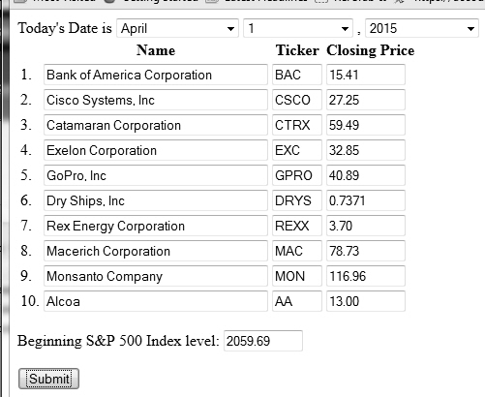

With PHP, it’s possible to set up the Dart Portfolio during class while students are throwing the darts. Exhibit 1 shows the web page where the names, tickers, and closing prices of the stocks that are selected by the darts are entered. Since I usually teach this course in the evening, the markets are closed and the closing price is the most recent price. However, if the course is taught during the day when the markets are still open, the most recent market price can be used as a starting point. Students never actually see the input page because it is running on a computer that isn’t connected to the overhead projector. The lectern computer is used to find prices which are projected for the class to see. Once the date of creation for the portfolio has been set and the names, tickers, and closing prices of all ten stocks have been recorded, the only thing that remains is to input the closing value of the S&P 500 index and click the submit button. The input page submits all of the data to a MySQL database, and the portfolio can then be shown to the class on the overhead projector. Exhibit 2 shows the sample portfolio of stocks submitted from the Exhibit 1 input page:
Exhibit 2: Dart Portfolio Display Page
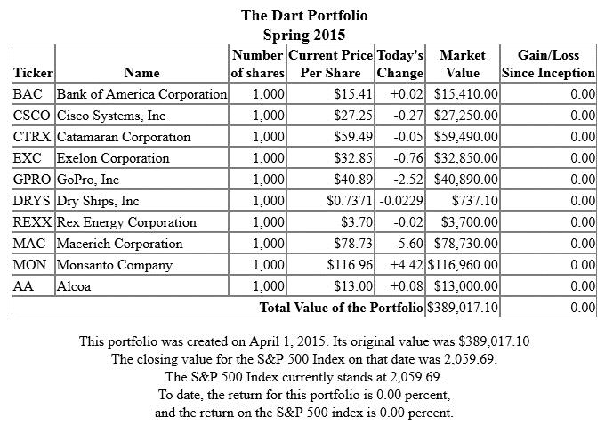

Once the portfolio is available for students to view, I spend a few moments discussing some of the features of the portfolio such as the fact that although there is an equal number of shares of each stock, the market value of each stock in the portfolio varies dramatically. I also ask students to point out any of the companies in the portfolio with which they are familiar. In this example portfolio, students would probably be familiar with Bank of America, Cisco Systems, and GoPro. The unfamiliar companies are explored later in the term.
In fact, the portfolio will play an essential role throughout the term. In addition to familiarizing students with the different types of companies that issue securities, the portfolio stocks can be used to teach about financial ratios, stock valuation, dividend policy, risk and return, diversification, benchmarking, market indexes, stock splits and so forth. It offers students a practical real world look at the tools and techniques they are learning in the course. Of course, the portfolio is also a great resource for exam questions. Not only do I not have to resort to the tired, old hypothetical Company X, I can use real world information that is familiar to my students. In fact, students often comment to me after a test that they noticed that a certain question was based on one of the stocks in our Dart Portfolio.
Unlike other portfolio trackers on the web, my PHP-generated portfolio does not automatically account for stock splits or stock dividends. There are two approaches to dealing with a stock split should one occur during the term. The first approach is to tell students on the first day of class about stock splits and their possible effect on the portfolio. Students can then be directed to a stock splits calendar, such as the one at Stock Splits.net (http://www.stocksplits.net/splits.htm), where they can search the coming months to see if any of the Dart Portfolio stocks have set a date for a stock split. If any are found, the class can then discuss how this should be handled in the portfolio. The second approach is to do nothing and wait. If a split happens, it gives me the opportunity to ask the class why the price of the affected stock fell so dramatically. Either way, I must manually adjust the price and number of shares in the PHP document to reflect the split.
The Dart Portfolio is a wonderful tool that is used throughout the class. It gives students concrete, real world examples to work with and makes learning finance relevant. The example portfolio can be viewed at http://finance.ewu.edu/finc335/portfolio3.php.

An Interactive Risk Test from Fundamentals of Investments: Valuation and Management
The success of the Dart Portfolio led me to investigate other uses for web technologies. I have used Fundamentals of Investments: Valuation and Management by Jordan, Miller and Dolvan for many years in my investments course and have often wanted to require my students to take the risk tolerance quiz found in the Chapter 2 Investment Updates sidebar entitled “Bumpy Market Reminds Investors to Assess Their Risk Tolerance.” (Jordan, Miller and Dolvan, 2015, pp. 43-45) Unfortunately, since the process of calculating an individual’s risk score by hand is cumbersome, I never assigned it to my students. I didn’t trust that the students would be able to accurately calculate their own scores, but I didn’t want to spend time calculating scores for them. So I simply pointed out the quiz and encouraged them to take it. “Why,” I wondered, “didn’t the publishing companies activate items such as the risk tolerance quiz in their e-Books, allow students to take the quiz online, and calculate the risk score for them?” E-Books would be much more inviting to students if they were filled with useful interactions such as this that encouraged students to become active learners instead of passive readers of electronic documents. Instead of waiting for the publisher to take action, I decided to create a page in PHP that would allow students to take the quiz online. (See Exhibit 3)
Exhibit 3: Online Questions for the Risk Tolerance Quiz
Once a student has answered all of the questions and submits them, he or she immediately receives their risk score along with the Suitable Investments table, found in Jordan, Miller, and Dolvan that describes suitable types of investments for persons within given risk score ranges.

Exhibit 4: Risk Score and Explanation
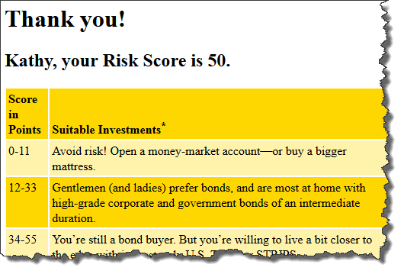

All of the answers submitted by the students along with their risk scores are posted to a database, which I can check periodically in order to see if students have completed the assignment. I now use the risk tolerance quiz in my investments classes as well as my personal finance classes. It’s very easy for students to complete and gives them instant feedback. In this day and age of wireless internet access, many students complete the quiz in class immediately after I assign it.
Cases
Cases are a powerful tool for learning and applying financial concepts. However, there are two issues that make cases problematic. First, cases tend to be either too simplistic or too complicated. There is no technological solution to address this issue; it can only be overcome by carefully reading scores of cases and selecting the best ones for classroom use. The second issue is that if a single static case is assigned to the class, there is a great temptation to cheat when the numeric answers to the case are the same for every student. Algorithmically generated homework problems and test questions are fairly common nowadays but not algorithmically generated cases. There are two cases that have both been published in The Journal of Financial Education that I like to use: the first is “George Tanaka’s Coffee Farm” (Maris, 2007) and the second is “Buffalo Flats and Eastern Railroad (BF&E).” (Rozycki, 2011) My approach to both of these cases was to randomly generate variables for the numbers in each case using PHP. In this paper, I will focus on the BF&E case because I was especially interested in the article’s description of a way to use Excel to perform Monte Carlo simulations without any special add-ins. In essence, I took Rozycki’s static case and wrote a PHP program that created several randomly generated variables for the case making each student’s solution to the case unique. The PHP program also calculated the solutions to each student’s case. I printed out a unique version of the case for each of the students in the course. The case was completed in two stages; the first stage required students to develop their unique version of the static capital budgeting worksheet described in Rozycki (pp. 103-104). After students successfully completed the static worksheet, they were given a copy of Rozycki’s article, which they then used to convert their static worksheets into Monte Carlo simulations. Exhibit 5 shows part of the unique static cases that were generated by my PHP program for three hypothetical students. Differences in each case are highlighted.
Exhibit 5: Algorithmically Generated BF&E Cases
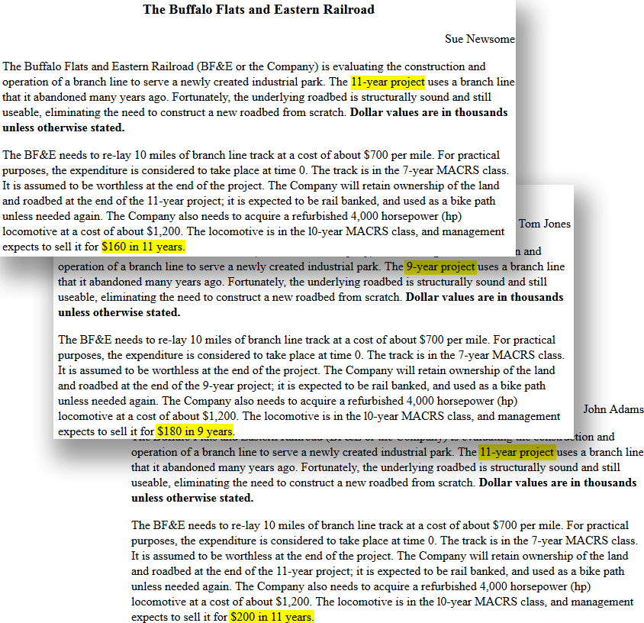

Since this was one of my first attempts at creating algorithmically-generated cases, only a few variables were selected for random generation: the life of the project ranged from 8 to 11 years, the sale of the locomotive at the end of the projected ranged from $160,000 - $240,000, the number of carloads generated per year ranged from 3,600 to 5,200, and transportation expenses as a percentage of revenue ranged from 27 to 37 percent. Exhibit 6 shows the solutions for the case assigned to hypothetical student Sue Newsome.
The algorithmically generated cases worked very well. Although each case had a unique solution, the cases were similar enough that students could benefit from working together on them with less danger of one person simply copying another person’s spreadsheet. The solutions generated by the PHP program allowed me to grade my students’ spreadsheets fairly quickly and provide them with suggestions for improving their spreadsheet before they attempted Rozycki’s Monte Carlo procedure.
Algorithmically Generated Exams
Has this ever happened to you? My colleague was ill so I volunteered to proctor his final exam. A few minutes into the exam a student raised his hand and asked me to explain the following question:
Adam wants to buy a new $28,000 Toyota Prius. However, her [sic] previous bankruptcies make it impossible for her [sic] to borrow any money. As a result, he has to pay cash for the car. He doesn’t have any cash now. However, he has set a goal to save some money at the end of each month for six years to save up the $28,000 he would need. Assuming that he could earn 7.2% interest, compounded monthly, on his savings, how much would he need to save at the end of each month so that he would be able to buy a $28,000 Prius five [sic] years from now?
I looked at the problem, scratched my head, and told the student to choose either six years or five years, it didn’t really matter. My colleague made four versions of each test in order to reduce cheating but, unfortunately, failed to take the time to carefully proofread each version. This question was supposed to be a revision of the following question:
Jennifer wants to buy a new $25,000 VW Bug. However, her previous bankruptcies make it impossible for her to borrow any money. As a result, she has to pay cash for the car. She doesn’t have any cash now. However, she has set a goal to save some money at the end of each month for five years to save up the $25,000 she would need. Assuming that she could earn 6.6% interest, compounded monthly, on her savings, how much would she need to save at the end of each month so that she would be able to buy a $25,000 VW Bug five years from now?

Exhibit 6: Solutions for Sue Newsome
Year | 0 | 1 | 2 | 3 | 4 | 5 | 6 | 7 | 8 | 9 | 10 | 11
Revenues |  | $4,160.00 | $4,284.80 | $4,413.34 | $4,545.74 | $4,682.12 | $4,822.58 | $4,967.26 | $5,116.28 | $5,269.76 | $5,427.86 | $5,590.69
Maintenance |  | 832.8 | 857.78 | 883.52 | 910.02 | 937.32 | 965.44 | 994.41 | 1,024.24 | 1,054.97 | 1,086.62 | 1,119.21
Transportation expenses |  | 1,248.00 | 1,285.44 | 1,324.00 | 1,363.72 | 1,404.63 | 1,447 | 1,490.18 | 1,534.88 | 1,580.93 | 1,628.36 | 1,677.21
Depreciation |  | 1,120.30 | 1,930.30 | 1,397.10 | 1,012.54 | 735.74 | 712.84 | 703.70 | 390.80 | 78.72 | 78.60 | 39.36
Earnings before interest and taxes |  | 958.90 | 211.28 | 808.72 | 1,259.46 | 1,604.42 | 1,697.52 | 1,778.97 | 2,166.35 | 2,555.15 | 2,634.28 | 2,754.91
Taxes |  | 335.62 | 73.95 | 283.05 | 440.81 | 561.55 | 594.13 | 622.64 | 758.22 | 894.30 | 922.00 | 964.22
Earnings after taxes |  | 623.29 | 137.33 | 525.67 | 818.65 | 1,042.87 | 1,103.39 | 1,156.33 | 1,408.13 | 1,660.85 | 1,712.28 | 1,790.69
Add depreciation |  | 1,120.30 | 1,930.30 | 1,397.10 | 1,012.54 | 735.74 | 712.84 | 703.70 | 390.80 | 78.72 | 78.60 | 39.36
Operating cash flows |  | 1,743.59 | 2,067.63 | 1,922.77 | 1,831.19 | 1,778.61 | 1,816 | 1,860.03 | 1,798.93 | 1,739.57 | 1,790.88 | 1,830.05
Net working capital | 100 | 416.00 | 428.48 | 441.33 | 454.57 | 468.21 | 482.26 | 496.73 | 511.63 | 526.98 | 542.79
Δ net working capital | -100 | -316.00 | -12.48 | -12.85 | -13.24 | -13.64 | -14.05 | -14.47 | -14.90 | -15.35 | -15.81 | 542.79
Cost of tracks | -7,000.00
Cost of locomotive | -1,200.00
Sale of Locomotive |  |  |  |  |  |  |  |  |  |  |  | 160
Tax on Sale of Locomotive |  |  |  |  |  |  |  |  |  |  |  | -56.00
Net cash flows | -8,300.00 | 1,427.59 | 2,055.15 | 1,909.92 | 1,817.95 | 1,764.97 | 1,802.18 | 1,845.57 | 1,784.03 | 1,724.22 | 1,775.08 | 2,476.84

- The NPV at 10% is $3,549.15
The NPV at 20% is -$504.15
- The IRR is 18.3349%

Stylistic issues aside, the problems encountered by my colleague writing several versions of a test could be easily avoided with a carefully constructed problem written in either PHP or JavaScript. Exhibit 7 shows the advantages of writing this problem in PHP:
Exhibit 7: Algorithmically Generated Test Problems
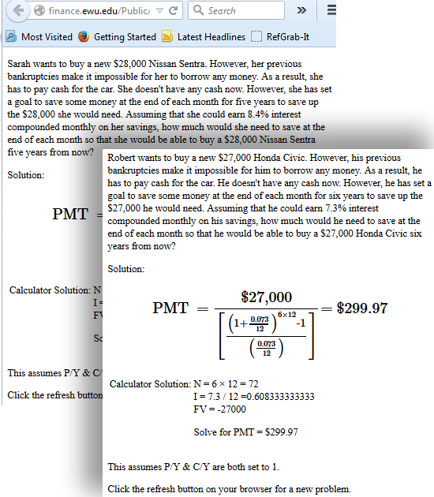
The PHP page that generated different versions of the above problem can be viewed at http://finance.ewu.edu/Public/gender_problem.php
In this instance, for each problem the pronouns match the gender of the name and the years of saving are consistent throughout. With a click of the browser refresh button, a new problem can be created then cut and pasted into a test. Furthermore, the solution for this new problem can be quickly transferred to the test key. Using such methods gives an instructor access to a huge number of accurate revisions for this particular problem.
This has been such a useful tool that I now use either PHP or JavaScript to generate all of my exams — printed or online. Most of my printed exams are written in PHP. However, HTML5 used along with JavaScript and Cascading Style Sheets (CSS) offers some very useful features for developing new teaching and learning tools, but before addressing HTML5, let’s look a little closer at the process of test generation using PHP.
There is no denying it, it takes a great deal of time to write an exam in PHP, but the benefits are well worth the effort. Once a test has been written, it can be opened in a web browser and printed. I then take the test myself noting any errors on the printed version of the exam. The errors are then corrected in a static html version of the exam and photocopies are made for the students. If more than one version of the exam is desired, the above process is repeated after a new version of the exam is generated with a click of the browser’s refresh button.
A static version of an exam can be created by viewing the page source of an exam in the web browser, copying the html generated by the PHP page, and pasting it into an html file. Exhibit 8 shows how to view the page source in the Firefox web browser while Exhibit 9 shows how to use the Firefox menu to “select all” of the html to be copied and pasted into a new html document. Each PHP generated exam creates two versions of the exam; the first is a clean copy that can be printed and distributed to students on the day the test is administered. The second is an exam key which serves two purposes: (1) to use to grade exams, and (2) to be made available in an online test archive. I have been archiving my exams and making them available to students for several years now. When I first started teaching at the college level, I soon realized that members of fraternities and sororities had an unfair advantage because their houses collected old exams for their members to consult as they studied for exams. I decided to level the playing field in my classes by making old exams available online to all of my students. The test archive (See Exhibit 10) benefits me and my students. Since I write nearly all of the questions on my exams, students can get a good feel for my tests, my writing style, and my exam expectations. I benefit by having a well-organized structure for my old exams that can easily be referred to when I am in the process of writing new exams. The availability of the archive to students also forces me to be constantly looking for new and different ways to write questions.

Exhibit 8: Creating a Static Exam Document
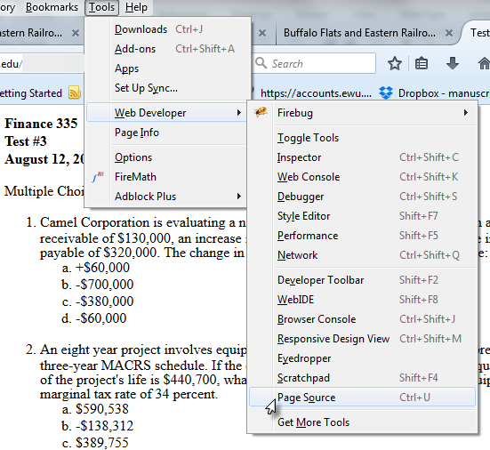

Exhibit 9: Cutting and Pasting PHP Generated HTML into a New Document
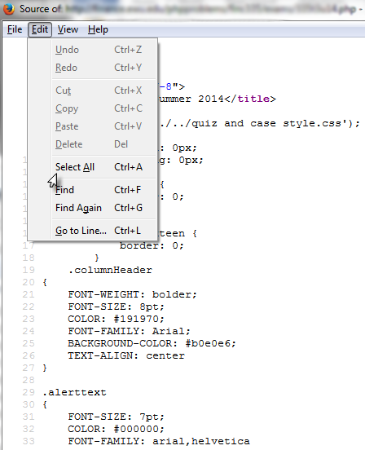

Exhibit 10: The Test Archive
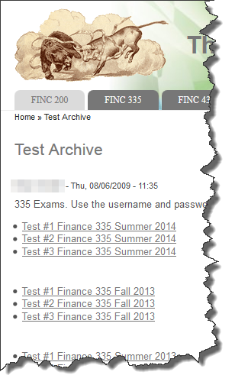

My test archive is password protected; I don’t want to write exam questions for others. However, a copy of one of my static PHP generated exams can be viewed at the following URL: http://finance.ewu.edu/Public/PHP_Static_Exam_Example.html
Useful Features in HTML5
One of the most exciting newer features of HTML5 is the Canvas tool (not to be confused with the LMS also known as Canvas.) According to Fulton and Fulton (2013), “HTML5 Canvas is an immediate mode bitmapped area of the screen that can be manipulated with JavaScript. Immediate mode refers to the way the canvas renders pixels on the screen. HTML5 Canvas completely redraws the bitmapped screen on every frame by using Canvas API calls from JavaScript.” This means that Canvas can be used for everything from drawing a static graph to creating interactive video games such as Angry Birds™. Exhibit 11 depicts a standard graph often used to show the risk-reducing benefits of diversification. This graph was created using the HTML5 Canvas tool.
Exhibit 11: Portfolio Risk Graph Created with HTML5 Canvas
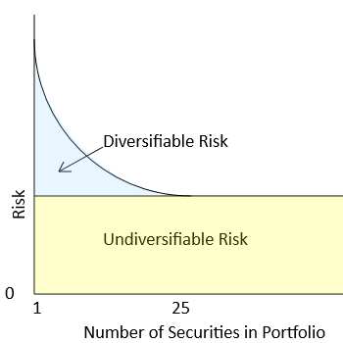
There are several advantages to using Canvas to create images. First, unlike a jpg or gif file, these images can be magnified with less distortion or pixilation. This makes them very useful for enlarging and displaying in a classroom. Second, although the image in Exhibit 11 is static, the Canvas tool can be used to easily make it interactive so that students could use a device such as a slider to increase the number of assets in the portfolio and then watch as the risk of the portfolio falls. Third, jpg or gif images can be created from a Canvas display simply by right-clicking on the display and choosing the “Save Image as” option.
HTML5 Canvas along with JavaScript and CSS3 can also be used to generate exams. Exhibit 12 is a screenshot of several exam questions that were written using HTML5. The timelines were created using Canvas and are dynamically generated. Note that cash flows in the exam question solutions, which are also dynamically generated, correspond to the cash flows on the timeline.

Exhibit 12: Exam Timeline Generated with HTML5 Canvas

Finally, it is possible to use PHP and HTML5 generated questions in learning management systems for online testing purposes. Our university uses the Canvas LMS, which has a quizzing feature that can be used to generate online exams. The grouping feature of Canvas allows several questions to be added to a group. Canvas then allows you to choose the number of questions to be randomly selected from each group. I create a group for each test question then randomly select one question from each group. Using PHP algorithmically generated test questions, I copy and paste ten different versions of each question into its corresponding group in the Canvas LMS quiz. For short answer questions, I also create an html document with solutions for each version. Exhibit 13 shows a group of short answer questions in a Canvas LMS quiz.
Exhibit 14 shows a portion of the html solutions document used for grading this short-answer question. Using dynamically generated test questions in Canvas LMS groups allows me to create online exams that are very similar to the exams that are given in the traditional classroom. Each online exam is unique because it randomly selects different versions of each question from a group of ten variations. The multiple choice versions are automatically graded in the Canvas LMS, but the short-answer questions must still be graded by hand. All online exams are proctored and time limited in an effort to reduce cheating.

Exhibit 13: Canvas LMS Grouped Short-Answer Questions
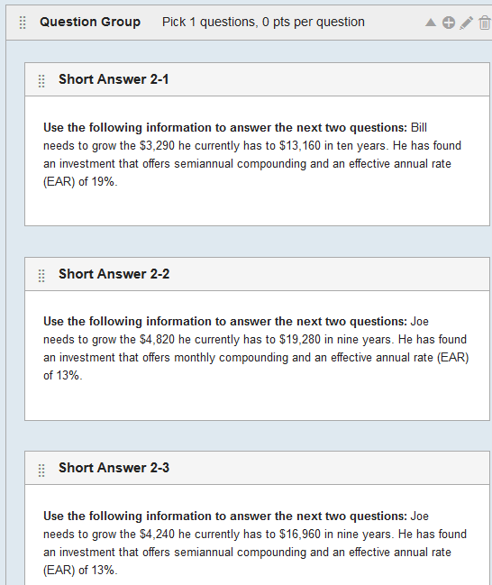

Exhibit 14: Solutions to Short-Answer Grouped Questions in the Canvas LMS
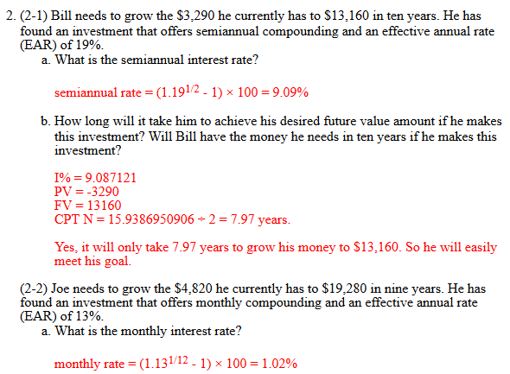

AACSB ASSESSMENT
Any accredited business school understands the need for effective assessment processes that “close the loop” in an effort to improve student learning. Technology, of course, offers many opportunities to aid in the assessment process. Testing results in my introductory finances courses indicated that students were having problems with bond yield to maturities (YTM) and with finding the after-tax salvage value of equipment under consideration for a capital budgeting project. The former issue was mostly a matter of understanding how to use a financial calculator to calculate YTM while the latter problem arose primarily from an inability to calculate the equipment’s book value.
The YTM issue was addressed by placing more emphasis on the process in the lecture. Furthermore a number of technologies were employed to help students learn how to find a bond’s YTM. In my course, I recommend that students keep the P/Y and C/Y inputs on their financial calculators set to one. Adjustments can then be made to the number or periods input (N) and the interest rate input (I% or I/Y) when dealing with compounding that occurs more frequently than once a year. This means that when a student calculates a bond’s YTM, the result produced by the calculator is a semi-annual yield that must be multiplied by 2 to find the annual YTM as it is traditionally calculated. This last step was being omitted by too many students. To address this problem, I created an HTML5 webpage that employs JavaScript and videos to teach students how to calculate YTM. Exhibit 15a is a display of the aforementioned web page which includes some common input errors.
Exhibit 15a: Online YTM Tutorial – Incorrect Inputs
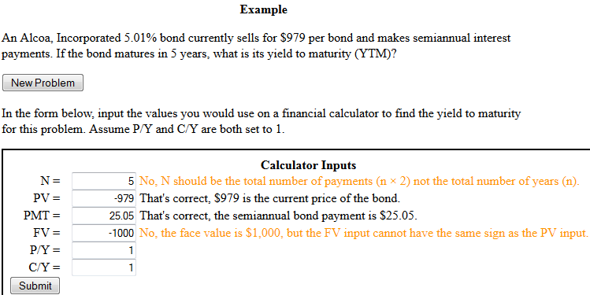
This web page may be viewed at the following URL: http://finance.ewu.edu/finc335/lectures/Ross Westerfield Jordan/Yield to Maturity.html

The first input error is that the N input should reflect the total number of semiannual periods, not the total number of years. The second input error is that the FV input and the PMT
Exhibit 15b: Online YTM Tutorial – Correct Inputs
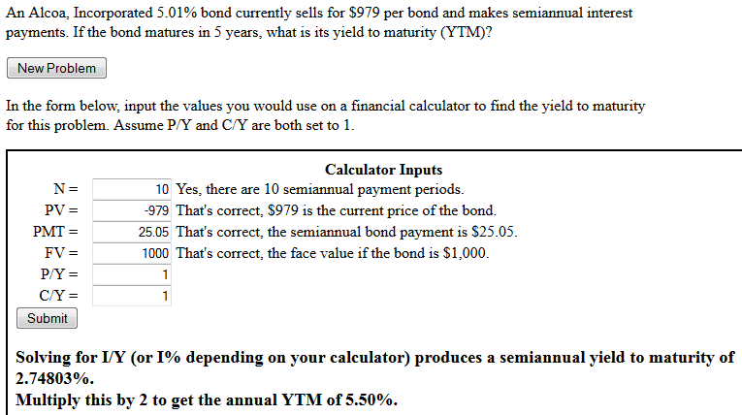
input have opposite signs. This common error leads to incorrect results when using a financial calculator. Feedback is given to the students and corrections can be made to their inputs. Once the inputs are correct, the page calculates the semiannual YTM and instructs the student to multiply it by 2 to find the annual YTM. (See Exhibit 15b)
If the student wants another practice problem, they can click the “New Problem” button, which generates a new problem and clears the student’s previous inputs. I also include some video tutorials on this page below the YTM exercise that explain how to calculate YTM with a TIBAIIPlus, a TI84, and an Excel Spreadsheet.
Before implementing the online learning tools mentioned above, 68% of the students in the winter 2013 course were able to calculate the YTM for a bond that makes semiannual interest payments on an exam. After the learning tools were introduced, 73⅓% of the students in the spring 2013 course were able to successfully calculate the YTM. Although the target for improvement was 75%, this information was used as evidence for closing a loop in our college’s AACSB reporting.
Calculating book value has long been problematic for many of my students, which means that they cannot properly determine the tax on the sale of equipment when a capital budgeting project terminates. To address this problem, I developed an HTML5 page that helped students calculate book value using the methods employed in Fundamentals of Corporate Finance (Ross, Westerfield and Jordan, 2010).

Exhibit 16: Determining Book Value
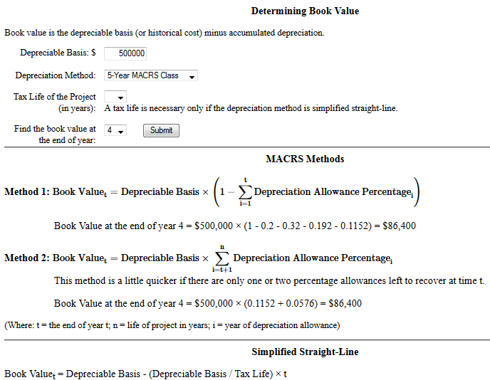
This web page may be viewed at the following URL: http://finance.ewu.edu/finc335/lectures/Ross Westerfield Jordan/Determining Book Value.html

Exhibit 16 is a screenshot of the web page that helps students learn how to calculate book value. Exhibit 17 shows the special case of simplified straight-line, which is used in Ross, Westerfield, and Jordan (2010) and cannot be ignored if an instructor chooses to use Connect for homework assignments.

Exhibit 17: Determining Book Value Using Simplified Straight-Line
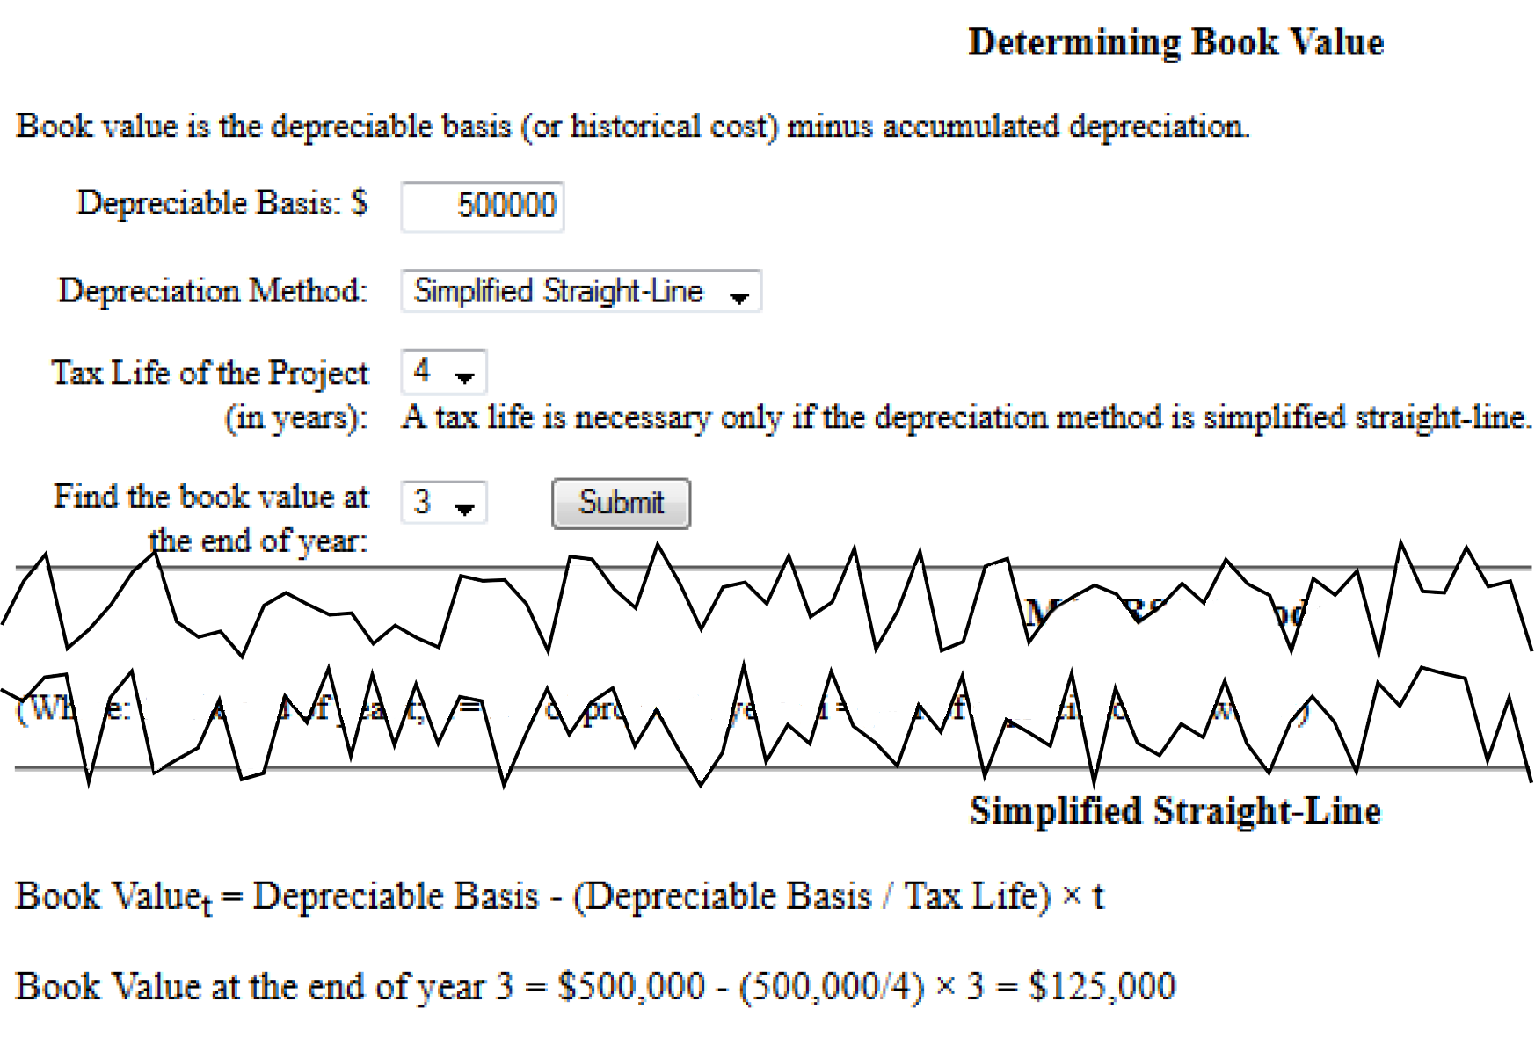

No before and after measures for assessment were performed with the Determining Book Value web page. However, it is a useful tool to bring to the attention of students who are struggling with calculating book value, and it can also be used in class to demonstrate how to calculate book value.
FUTURE USES
The future of web-based teaching and learning tools is only limited by our imaginations. Many of these technologies are free and fairly easy to learn. There is a great deal of help available on the web for anyone who is willing to take the time to learn how to use these tools.
Possible future applications include the development of smartphone learning apps for students. Other applications will revolve around new advances in web page development. I have written my lecture notes in html for several years now, which allows me to develop interactive tools that can be directly embedded into the lecture notes. HTML5’s Canvas tool holds a great deal of promise. Its ability to create interactive applications makes it useful for developing online features that can engage students as they learn. Since most of the tools I have built using Canvas lack any interactive components, I look forward to developing teaching and learning applications that make use of this important feature of HTML5 Canvas.

RESOURCES
This section provides a short list of resources for anyone who is interested in developing their own web applications
- If you're interested in setting up a test server:
  - "AMP" stands for Apache Server, MySQL Database, PHP
  - WAMP – Windows: http://www.wampserver.com/en/
  - MAMP – Macintosh: https://www.mamp.info/en/
  - LAMP - Linux
    - > sudo aptitude install apache2 php5 mysql-server php5-mysql libapache2-mod-php5
- Books
  - JavaScript & jQuery: The Missing Manual by Luke Welling and Laura Thomson (2009)
  - PHP Solutions: Dynamic Web Design Made Easy by David Powers (2010)
  - HTML5 for Masterminds: How to Take Advantage of HTML5 to Create Amazing Websites and Revolutionary Applications by J.D Gauchat (2012)
  - HTML5 and CSS3: Develop with Tomorrow's Standards Today by Brian P. Hogan (2010)
  - Developing Web Pages with jQuery by Don Gosselin (2013)
  - JavaScript & jQuery: The Missing Manual by David Sawyer McFarland (2012)
- Websites
  - php.net - http://php.net/
  - Dive Into HTML5 - http://diveintohtml5.info/
  - HTML5 Introduction - http://www.w3schools.com/html/html5_intro.asp
  - lynda.com – This site has great video tutorials on everything from PHP to JavaScript.
CONCLUSION
This is an exciting time to be teaching because there are so many web-based technological tools that are freely available to instructors. It is important for educators to use these tools wisely and to develop teaching and learning tools that are efficient and effective. The technology adoption process suggested earlier should start instructional developers on the right track. Educators must shape the way these tools are used for teaching and learning because they and they alone are in the best position to identify issues that can best be solved using technology. This is something that is simply too important to leave to textbook publishers or LMS providers.
It is also important that teachers share their technological developments with each other and encourage each other to use these tools to enhance the education of our students. Hopefully, this paper is a step in that direction.
REFERENCES
Fulton, J., and S. Fulton., 2013. HTML5 Canvas (O'Reilly, Farnham). 2nd edition.
Gauchat, J. D., 2012. HTML5 for Masterminds: How to Take Advantage of HTML5 to Create Amazing Websites and Revolutionary Applications (Mink Books, Toronto, Canada). 2nd Edition.
Gosselin, D., 2013. Developing Web Pages with JQuery (Cengage Learning, Boston).
Hogan, B. P., 2010. HTML5 and CSS3: Develop with Tomorrow's Standards Today (Pragmatic Bookshelf, Dallas, Texas).
Jordan, B. D., T. W. Miller and S. D. Dolvan., 2015. Fundamentals of Investments: Valuation and Management (McGraw-Hill, New York). 7th edition.
Malkiel, B. G., 1975. A Random Walk Down Wall Street (Norton, New York).
Maris, B. A., 2007. George Tanaka's Coffee Farm, Journal of Financial Education 33, 96-99.
McFarland, D. S., 2012. JavaScript & jQuery: The Missing Manual (O'Reilly, Sebastopol, Calif.). 2nd edition.
Metcalf, G. E., and B.G. Malkiel, 1994. The Wall Street Journal Contests: The Experts, the Darts, and the Efficient Market Hypothesis, Applied Financial Economics 4, 371-374.
Powers, D., 2010. PHP Solutions: Dynamic Web Design made Easy (Friends of ED, New York). 2nd edition.
Ross, S. A., R. Westerfield and B. D. Jordan., 2010. Fundamentals of Corporate Finance (McGraw-Hill Irwin, Boston).
Rozycki, J., 2011. Excel-Based Monte Carlo Simulation as a Capital Budgeting Risk Management Tool, Journal of Financial Education 37, 101-128.
Welling, L., and L. Thomson., 2009. PHP and MySQL Web Development (Addison-Wesley, Upper Saddle River, NJ). 4th edition.

