Solving Quantitative Problems in Finance: A Tool for Unlimited Practice

(Preliminary draft not to be cited or distributed without permission of author)

Howard Keen
Temple University
hkeen@temple.edu

Introduction

Students of Finance are repeatedly told that one “learns Finance by doing Finance” which suggests that practice is critical to learning how to solve quantitative problems in Finance. A big challenge faced by students, however, is that opportunities to practice are somewhat limited. While it’s true that there are online homework tools available from various commercial publishers such as Pearson’s MyFinanceLab© and McGraw-Hill’s Connect©, they are still limited in scope based on close ties to an underlying textbook or lack of an unlimited number of problems that an individual student can work. Not all instructors use such tools in their classes nor are willing to offer unlimited attempts for credit; publisher-provided tools may not cover topics covered in a course or more frequently may present topics in a way that is different from an individual instructor’s approach. This paper presents examples of how to develop a practice problem tool that is customized to the way in which the introductory corporate finance course is taught in a large state-supported university. The tool consists of a variety of simple spreadsheets that both offers students literally unlimited practice at solving for selected measures and at the same time, provides an opportunity for better understanding of the underlying framework used to solve for these measures. The spreadsheets are set up to enable students to supply the inputs, attempt to solve for the indicated variables(s) using any of a variety of methods, and then be able to check their answers against the correct answers that will appear in the spreadsheet.

Topics Covered

The following is a list of quantitative topics for which practice problem spreadsheets have been developed. It’s important to keep in mind that the particular topics and structure of the problems are based on the approach used in the course for which the author is the coordinator and are intended to be illustrative only. Individual instructors would be able to customize the tool to conform to the way in which they teach a particular topic.

- Time value of money (TVM) (lump sums and multiple cash flows)
- Compound vs. simple interest
- Fixed-payment loans
- Retirement planning
- Fisher Effect
- Bond prices and yields
- Annualized holding-period returns
- Reward - risk ratio
- Required return on equity (CAPM)
- Mean-Variance with Normal Distribution
- Stock pricing
- Impact of changes in expenses on net income and cash
- Cash Flow Identity components
- Break-even EBIT
- Financial ratios
- ROE per DuPont framework
- Annual straight-line depreciation
- Book value
- Cash flow from salvage
- Cost of capital (WACC)
- Net Present Value(NPV)
- IRR
- NPV Profile Graph

Practice Problem Spreadsheets

While spreadsheets have been developed for the full foregoing list of topics, we will select only one of those topics--TVM--to illustrate the use of this tool. The TVM problems consist of solving for the following: Each of the four variables in the lump-sum TVM formulas; compound versus simple interest; Present Value (PV) and Future Value(FV) of uneven multiple cash flows; PV and FV of an annuity; PV of an annuity with a delayed start; Fixed-payment mortgage loan parameters; and retirement planning parameters.

We begin with the problem of solving for each of the four variables in the lump-sum TVM formulas as illustrated in Figure 1.

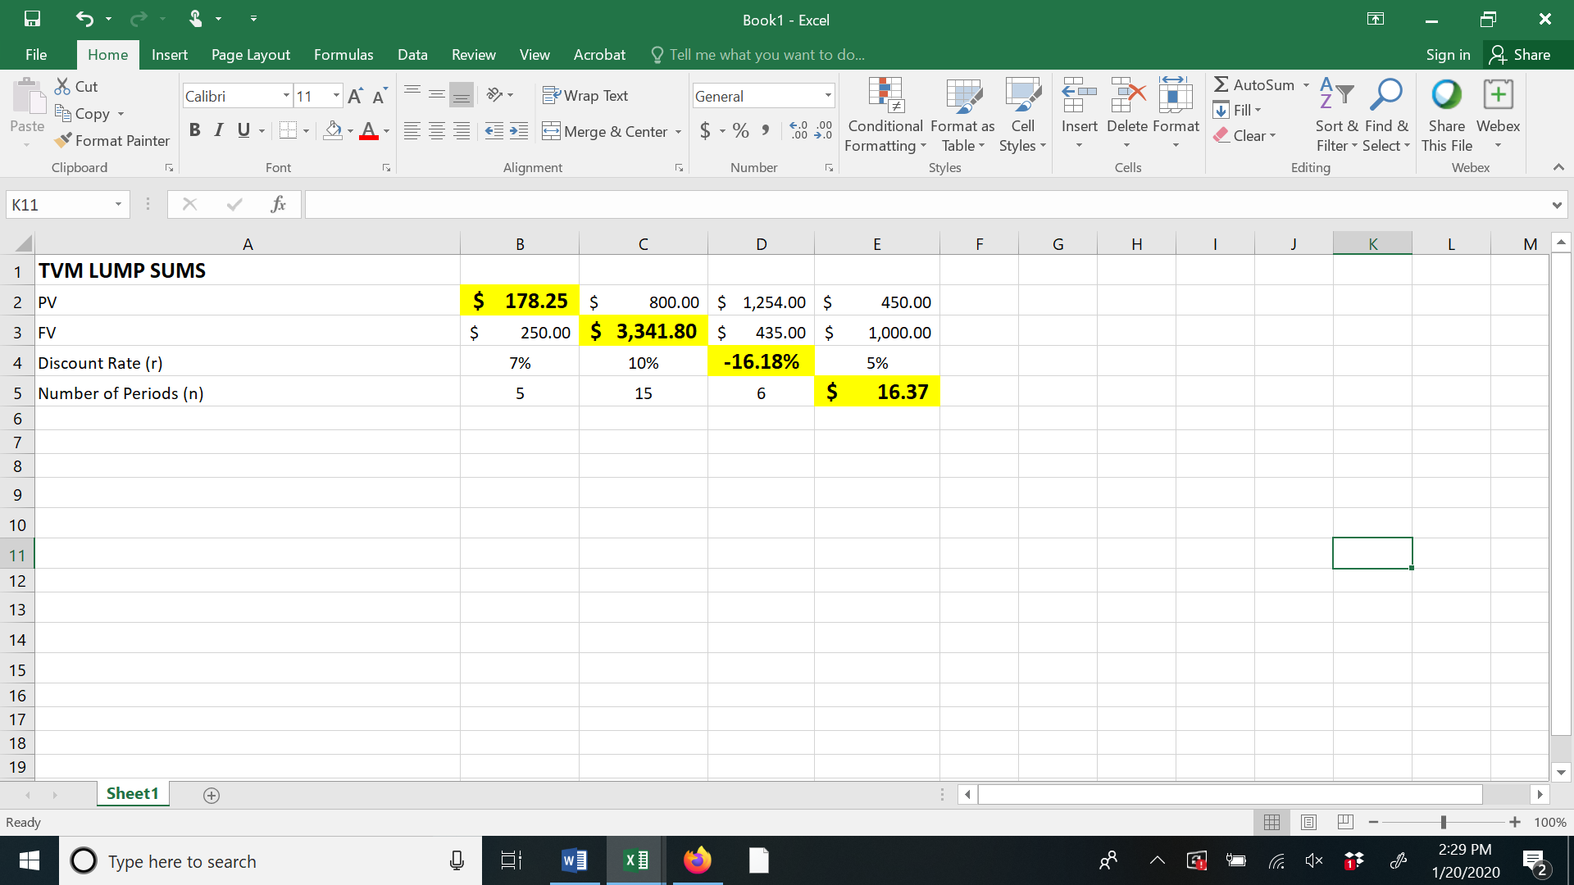

Figure 1

Column B illustrates the problem of solving for the PV. Students would enter as inputs three required arguments in the lump-sum PV formula--the FV, discount rate and number of periods in cells B3 through B5, respectively. The student would then be expected to solve for the PV in cell B2 using either a scientific or financial calculator. The student would then be able to compare their answer independently of the spreadsheet with the correct answer that appears in the yellow cell, B2. Similar use of this particular spreadsheet would provide practice in finding solutions for the FV, discount rate and number of periods in columns C through E, respectively. Two aspects of this are noteworthy: students can literally practice the calculations an unlimited number of times--limited only by the number of sets of different inputs or arguments that they choose to enter--and they have the opportunity to actively participate in setting up the problem by being required to provide the inputs. The latter aspect can possibly aid students’ understanding of the structure of a problem by giving them a broader perspective.

We turn next to a problem comparing compound to simple interest earned over both a multi-year period and for a single year which is illustrated in Figure 2.

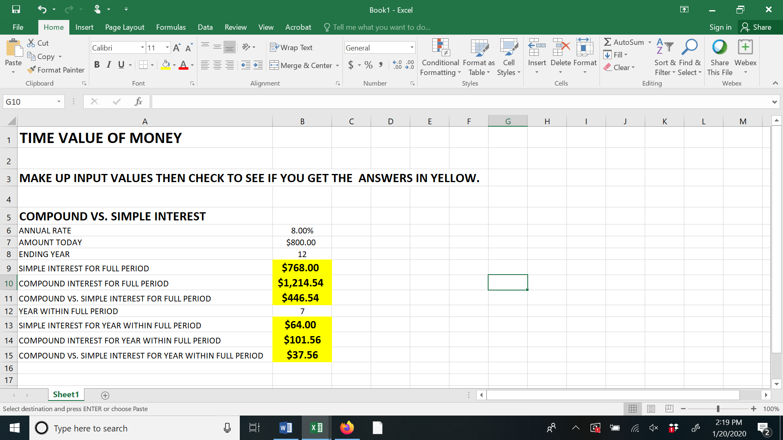

Figure 2

Students would provide the inputs--the annual rate, starting amount and the number of years in cells B6 through B8, respectively. Students would then be expected to solve for the simple and compound interest for the full period and the resulting difference--cells B9 through B11. Students then select an individual year within the full period in cell B12, such as year 7 in the example illustrated, and then would solve for the simple and compound interest and the resulting difference for year 7 alone in cells B13 through B15, respectively. For each of the calculations, students would be able to compare the answers they got independently from the spreadsheet with the correct answers that appear in the yellow cells.

Problems involving the TVM of multiple cash flows are illustrated in Figures 3, 4 and 5. In particular, five types of problems are illustrated here: Figure 3 illustrates problems involving the PV and FV of an uneven stream of multiple cash flows; the PV and FV of an annuity; and a perpetuity with a delayed first payment. Figure 4 presents a retirement planning application and Figure 5 a fixed-payment mortgage loan application.

For the problems involving uneven multiple cash flows in Figure 3, students supply cash flows for today and then one and two years out in cells B3 through B5, respectively, along with an annual interest rate in cell C3. After solving for the PV and FV of the uneven stream independently of the spreadsheet, students can then compare their answers to those in cells B10 and B11. Problems involving annuities are covered in columns E and F. Students input the payment, number of years and the annual rate in cells F2 through F4, respectively, solve for either the FV or PV independent of the spreadsheet and then compare answers with those in cells F6 and F7. The next problem involving multiple cash flows posits a perpetuity with a delayed first payment. This problem is covered in our introductory corporate financial management class to provide a better understanding of the timing of values derived from the formulas of the PV of an annuity and PV of a perpetuity and to provide practice in combining the PV of multiple cash flows and the PV of a lump sum. Students provide the perpetuity amount, the year of the first payment and the annual rate in cells I2 through I4, respectively, then independent of the spreadsheet, solve for the value of the perpetuity one year before the first payment (in cell I5) as well as for the value today (cell I6).

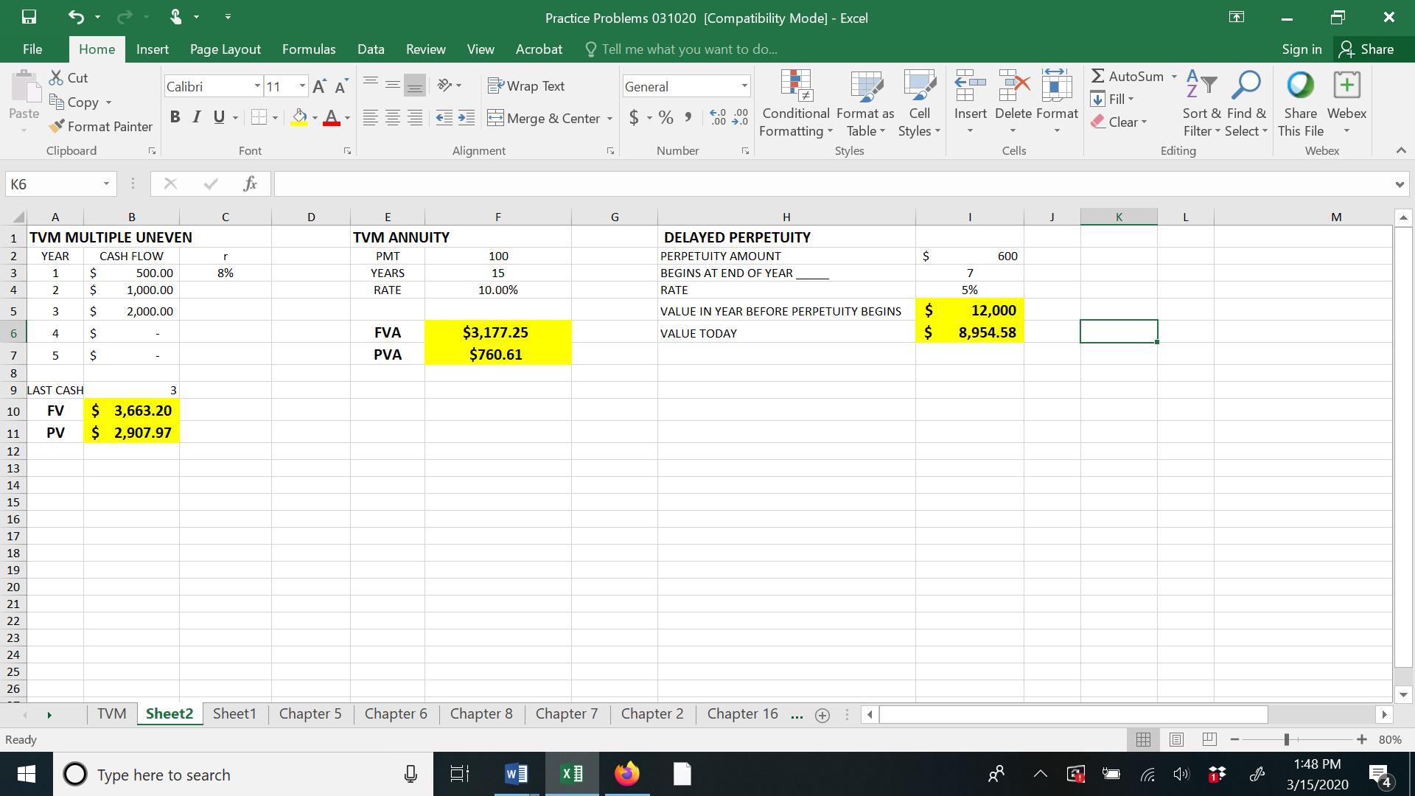

Figure 3

Figure 4 presents two very common applications of multiple TVM. Columns E through G, respectively, illustrate problems involving the amount needed at the beginning of retirement, the annual savings required during working years and the amount available for annual withdrawals during the retirement period. Again, students input arguments in the non-yellow cells, work the solutions independent of the spreadsheet and then can check the correctness of their answers with those in the yellow cells. As with the problems discussed above, students can literally practice this problem an unlimited number of times--limited only by the inputs or arguments that they choose--and they have the opportunity to actively participate in setting up the problem through the opportunity to provide the inputs.
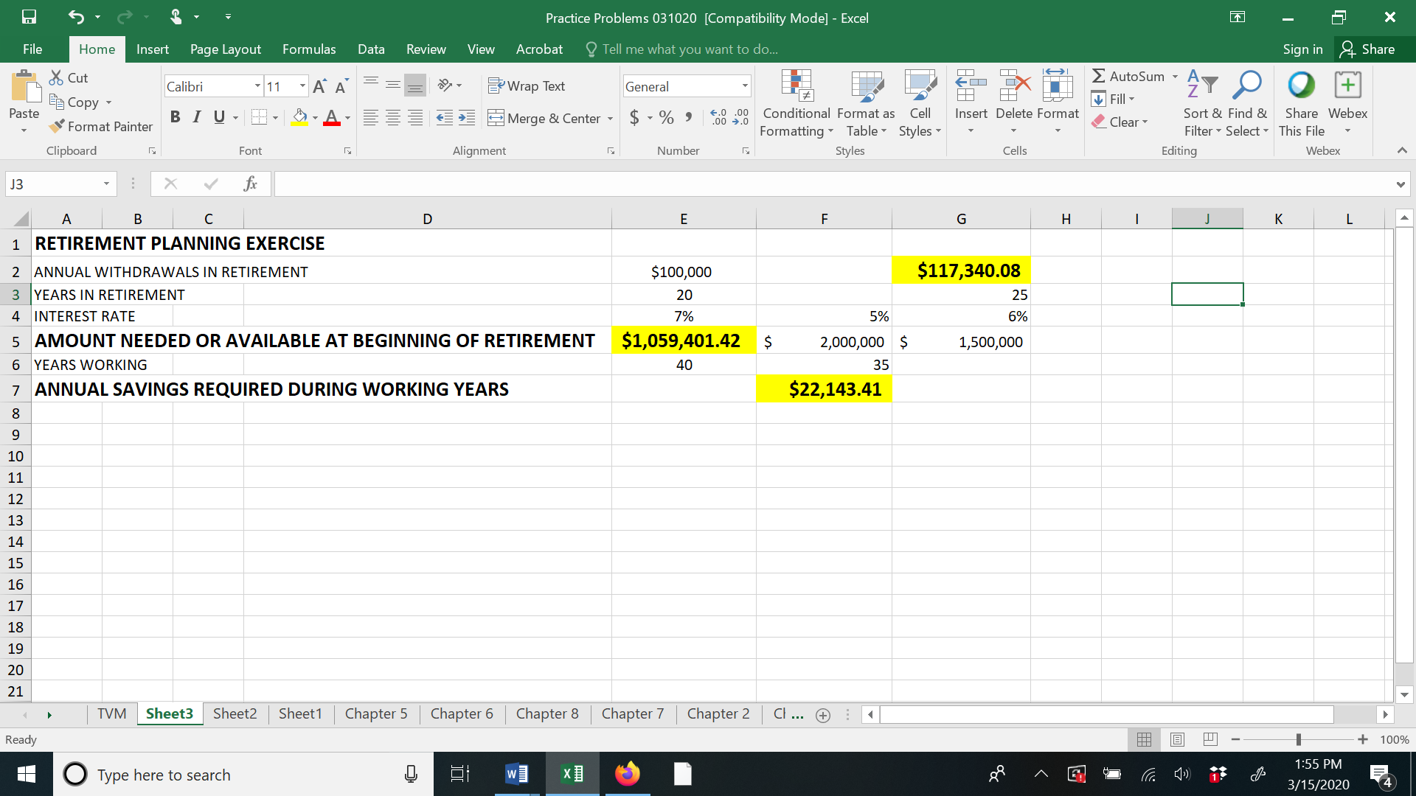

Figure 4

The final set of problems involves fixed-payment fully amortized loans as illustrated in Figure 5. Cells B5 and B6 offer the opportunity to solve for fixed payments for annual and monthly loan payments, respectively while cells C2 and D2 for loan amounts. Students would enter values for the loan amount, loan term and annual interest rate in cells B2 through B4, respectively and can then check their solutions for both annual and monthly fixed payments in cells B5 and B6, respectively. Additionally, there is the opportunity to solve for the first payment row of the loan amortization table for both annual- and monthly-payment loans in rows 11 and 12, respectively.

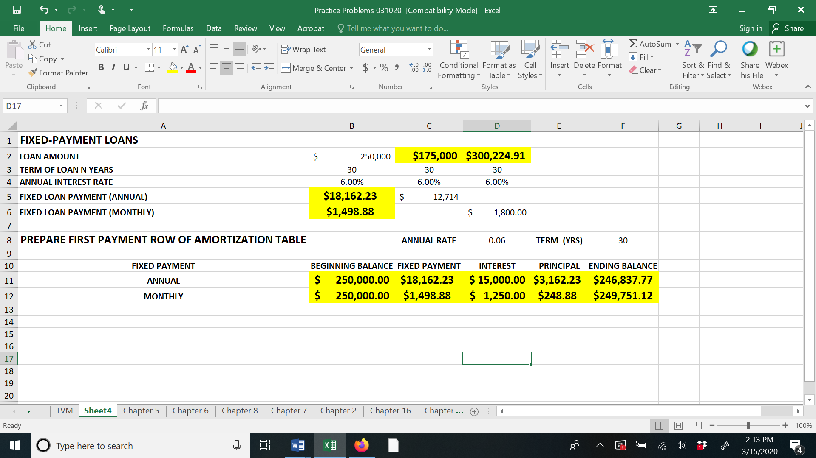

Figure 5

Conclusion

In addition to providing the opportunity for unlimited practice in solving quantitative problems, it is hoped that enabling students to supply the inputs (arguments) will give them a greater understanding of the totality of the framework in use rather than just focusing on coming up with the correct answer. An assessment of the impact of having a tool like this available will be made by analyzing performance on the quantitative portion of the exams given in an introductory corporate finance course.

With regard to instructors, no two instructors necessarily present a given topic in exactly the same way. The specifics of the spreadsheets presented in this paper reflect the unique way in which topics are presented in Temple University’s (Introductory) Financial Management course. Although the specific spreadsheets presented in this paper may not reflect precisely how other instructors might present the material, what is provided here can serve as a template to which other instructors can make modifications based on their particular approach to the subject.

In short, the spreadsheets presented in this paper can help students practice and have a broader appreciation of the framework within which a problem is solved and can also help instructors develop a tool unique to their approach to covering a given topic in a corporate finance course.

Note: Full Excel file containing spreadsheets for all topics listed in the “Topics Covered” section above can be attached.

